

**VALLURUPALLI NAGESWARA RAO VIGNANA JYOTHI INSTITUTE OF ENGINEERING AND TECHNOLOGY**

Vignana Jyothi Nagar, Pragathi Nagar, Nizampet (S.O), Hyderabad – 500 090, TS, India

WEATHER APP USING OPEN_WEATHR API

A course project submitted in complete compliance with the requirements for the award of the degree of

**BACHELOR OF TECHNOLOGY IN**

**INFORMATION TECHNOLOGY**

Submitted by

Ms. B JEEVIKA (20071A12C5)

Ms. B SANDHYA (20071A12C6)

Mr. B.KARTHIK (20071A12C7)

Ms. B SAHITHI (20071A12C8)

Under the guidance of

**V.MANOJ KUMAR Associate Professor**

**DEPARTMENT OF INFORMATION TECHNOLOGY**



**VALLURUPALLI NAGESWARA RAO VIGNANA JYOTHI INSTITUTE OF ENGINEERING AND TECHNOLOGY**

Vignana Jyothi Nagar, Pragathi Nagar, Nizampet (S.O), Hyderabad – 500 090, TS, India

**DEPARTMENT OF INFORMATION TECHNOLOGY**

**CERTIFICATE**

This is to certify that the project report entitled “**WEATHERF APPLICATION USING OPEN_WEATHER API”** is a bonafide work done under our supervision and is being submitted by **B JEEVIKA (20071A12C5), B SANDHYA (20071A12C6), B KARTHIK (20071A12C7), B SAHITHI (20071A12C)** in partial fulfillment for the award of the degree of Bachelor of Technology in Computer Science and Engineering, of the VNRVJIET, Hyderabad during the academic year 2022-2023. Certified further that, to the best of our knowledge, the work presented in this thesis has not been submitted to any other University or Institute for the award of any Degree or Diploma.

**V.MANOJ KUMAR**

**Associate Professor CSE Department, VNR VJIET**

**Dr. D.SRINIVASA RAO**

**HOD IT Department**

**IT Department,**

**VNR VJIET**

**VALLURUPALLI NAGESWARA RAO VIGNANA JYOTHI INSTITUTE OF ENGINEERING AND TECHNOLOGY**

An Autonomous Institute, NAAC Accredited with ‘A++’ Grade NBA Accredited for CE, EEE, ME, ECE, CSE, EIE, IT B. Tech Courses Approved by AICTE, New Delhi,

Affiliated to JNTUH Recognized as “College with Potential for Excellence” by UGC ISO 9001:2015 Certified, QS I GUAGE Diamond Rated

Vignana Jyothi Nagar, Pragathi Nagar, Nizampet (S.O), Hyderabad – 500 090, TS, India

**DEPARTMENT OF INFORMATION TECHNOLOGY**



**DECLARATION**

We declare that the project work entitled “**WEATHER APP**” submitted in the department of Computer Science and Engineering, Vallurupalli Nageswara Rao Vignana Jyothi Institute of Engineering and Technology, Hyderabad, in partial fulfillment of the requirement for the award of the degree of **Bachelor of Technology** in **Computer Science and Engineering** is a bonafide record of our own work carried out under the supervision of **Dr. M. Gangappa, Associate Professor, Department of CSE, VNRVJIET**. Also, we declare that the matter embodied in this thesis has not been submitted by us in full or in any part thereof for the award of any degree/diploma of any other institution or university previously.

Place: Hyderabad

B JEEVIKA B SANDHYA B.KARTHIK B SAHITHI

(20071A12C5) (20071A12C6) (20071A12C7) (20071A12C8)

**ACKNOWLEDGEMENT**

Firstly, we would like to express our immense gratitude towards our institution VNR Vignana Jyothi Institute of Engineering and Technology, which created a great platform to attain profound technical skills in the field of Computer Science, thereby fulfilling our most cherished goal.

We are very much thankful to our Principal, **Dr. Challa Dhanunjaya Naidu,** and our Head of Department, **Dr. S. Nagini**, for extending their cooperation in doing this project within the stipulated time.

We extend our heartfelt thanks to our guide, **V.MANOJ KUMAR,** for her enthusiastic guidance throughout the course of our project.

Last but not least, our appreciable obligation also goes to all the staff members of the Computer Science & Engineering department and to our fellow classmates who directly or indirectly helped us.

B JEEVIKA (20071A12C5) B SANDHYA (20071A12C6)

B.KARTHIK (20071A12C7)

B SAHITHI (20071A12C8)

**ABSTRACT**

We Create a Weather App Using HTML, CSS, and JavaScript Codes. In this Weather app we will get weather information from weather API and deploy it on the network we will be using open weather map API so we will be suing this API specifically one called API for this project so this project will be completely responsive site.

**INDEX**

1.Introduction 7

2.Advantages 8

3.Software Requirement 10

4.Coding/Implementation 13

5Conclusion And Further Work 14

6.References 15

# INTRODUCTION

We Create a Weather App Using HTML, CSS, and JavaScript Codes. In this Weather app we will get weather information from weather API and deploy it on the network we will be using open weather map API so we will be suing this API specifically one called API for this project so this project will be completely responsive site.

Weather forecasting has been one amongst the foremost scientifically and technologically difficult issues round the world within the last century. Weather Forecast systems are among the foremost advanced equation systems that computer needs to solve. This most advances scientifically and technological modification is attributable to two factors: 1st, it’s used for several human activities and second, attributable to the resourcefulness created by the varied technological advances that are directly associated with this concrete analysis field, just like the evolution of computation and therefore the improvement in activity systems. Sometimes beauty cannot be defined in just words and statements. Those lovely flowers and blossoms in the spring, warm sunshiny days in the summer, freezing mornings and the beautiful snow in the winter. Certain changes in weather are always wonderful and cherishable. In some or other way our daily lives are dependant on the weather conditions. It has been always essential to know the regular updates of weather, as it continuously varies with every passing day.No one can imagine how the weather is going to be on a subsequent day. Definitely, the Weather forecast is a big thing that enabled many of us to stay notified about the changes in climatic conditions beforehand. It can be said that it is one of the greatest advancements of all time, mothered by innovative technologies and creative thoughts. The furtherance of the weather forecasting is the weather app development

# ADVANTAGES

**A.Understanding the behavior of the customer:**

In this competitive market, it has become essential for business organizations to understand the requirements of the customers. Furthermore, designing the applications that satisfy their demands helps you to generate high revenue for your business.

**B. Build Customer Loyalty**:

The primary aim of your weather app development Company is to obtain customer loyalty. By using the intuitive user interfaces you can engage your users efficiently.

**C. Amplify your profit rate**:

You can simply notice the escalation of traffic to your application, with the increase in consumer satisfaction. One simple thing that you have to follow is to render your customers with the best services.

**D. A powerful tool for marketing:**

An application is always a great medium to market your business. By justing offering the users with the fundamental features that can be easily understood by them, you can amplify your business.

**E. Forecast:**

F.Climate apps: Climate apps come with a hub of functions such as displaying the climate changes, current earth’s climate map around the globe etc. Apart from this, they show air temperature, sea level, percentage of CO2 in the air, gravity field, etc. some of the advanced apps also come with a feature of hurricane tracking.

**G. Image of changes:**

This type of app is much less popular in comparison to the above mentioned two, however it is quite fascinating. It displays the overall climate change that has taken place over the years or a specific period of time. It is mostly used for learning purposes.

# SOFTWARE REQUIREMENT

Requirements analysis in systems engineering and software engineering encompasses those tasks that go into determining the needs or conditions to meet for a new or altered product or project, taking account of the possibly conflicting requirements of the various stakeholders, analyzing, documenting, validating and managing software or system requirements.

Software requirements deal with defining software resource requirements and prerequisites that need to be installed on a computer to provide optimal functioning of an application

* VISUAL STUDIO CODE
* MERN Stack

## VISUAL STUDIO CODE:

Visual Studio Code combines the simplicity of a source code editor with powerful developer tooling, like IntelliSense code completion and debugging. First and foremost, it is an editor that gets out of your way. The delightfully frictionless edit-build-debug cycle means less time fiddling with your environment, and more time executing on your ideas. At its heart, Visual Studio Code features a lightning-fast source code editor, perfect for day-to-day use. With support for hundreds of languages, VS Code helps you be instantly productive with syntax highlighting, bracket-matching, auto-indentation, box selection, snippets, and more. Intuitive keyboard shortcuts, easy customization, and community-contributed keyboard shortcut mappings let you navigate your code with ease.

And when the coding gets tough, the tough gets debugging. Debugging is often the one feature that developers miss most in a leaner coding experience, so we made it happen. Visual Studio Code includes an interactive debugger, so you can step through source code, inspect variables, view call stacks, and execute commands in the console. VS Code also integrates with build and scripting tools to perform common tasks making everyday workflows faster. VS Code has support for Git so you can work with source control without leaving the editor including viewing pending changes diffs

## Requirements for Visual Studio Code Hardware

Visual Studio Code is a small download (< 200 MB) and has a disk footprint of <500 MB. VS Code is lightweight and should easily run on today's hardware.

We recommend:

* 1.6 GHz or faster processor
* 1 GB of RAM

## Platforms

VS Code is supported on the following platforms:

**MERN STACK:**

Web development is the building and maintenance of websites; it's the work that happens behind the scenes to make a website look great, work fast and perform well with a seamless user experience.

## JavaScript

JavaScript is a scripting, object-oriented, cross-platform programming language. ObjectsThe host environment can be connected to JavaScript and arranged ways to operate them. Standard libraries for objects are contained by JavaScript, for example, Array, Date, Math, and the essential components of programming languages, for instance, managers, control framework, and statements.

# 4. CODING AND IMPLEMENTATIONS

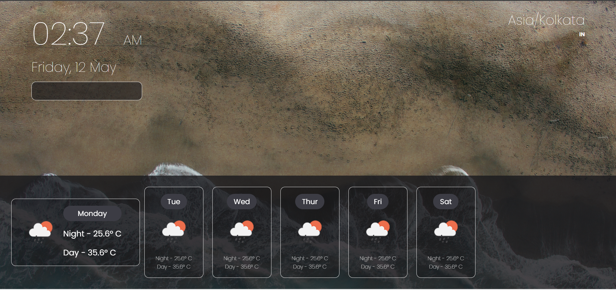

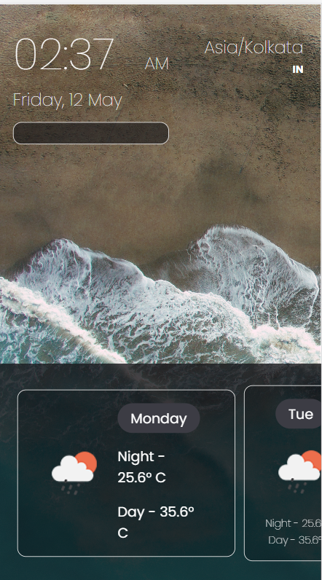

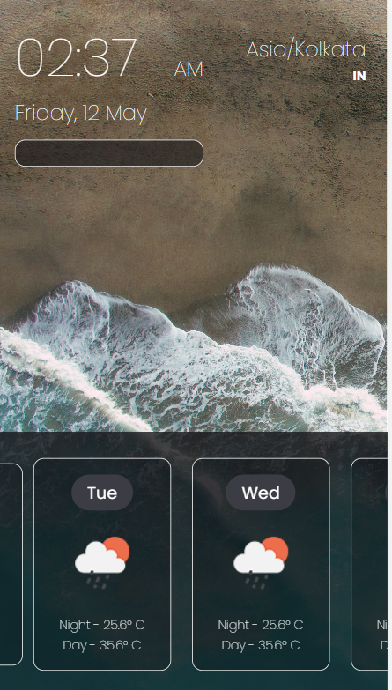

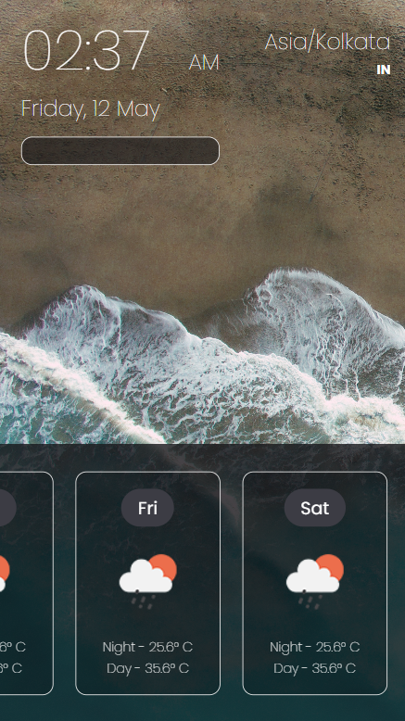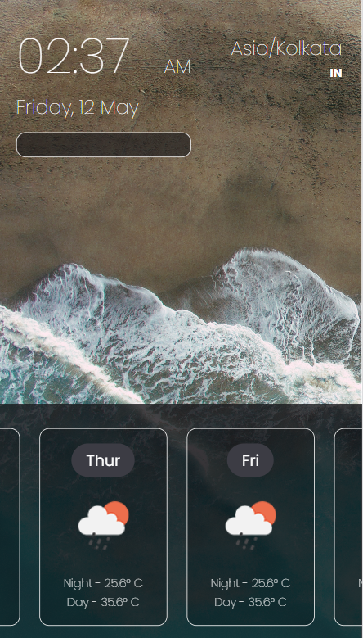

# 5. CONCLUSION

In conclusion, weather app is a web-based application that facilitates and allows users to check the weather updates. This innovation has revolutionized the way people do . eliminating the need for physical effort and saving time. For their Work. Weather app is a prime example of the potential of technology to enhance our lives and streamline our daily tasks.

So we conclude that we made a useful application for day to day life uses through which people can choose where and when to take their holidays to take advantages of good weather. Regions can be evacuated if hurricanes or floods are expected. Farmers can known when to plant or harvest their crops.

As our aim to is to provide the better weather forecasting than other platform so to take a edge we will not charge and it will be free of cost. So here we conclude that we have made a successfulapplication

# 6.REFERENCES

[1] Agrawal, R., Jain, R.C., Jha, M.P. and Singh, D. (1980): Forecasting of rice yield using climatic variables. Indian Journal of Agricultural Science, Vol. 50, No. 9, pp. 680-684. [2] Lee, S., Cho, S.& Wong, P.M., (1999) : Rainfall prediction using artificial neural network.― J. Geog. Inf. Decision Anal. 2, 233–242 1998. [10] Wong, K. W., Wong, P. M., Gedeon, T. D. & Fung, C. C. ―Rainfall Prediction Using Neural Fuzzy Technique. [3] C. Hamzacebi, “Improving artificial neural networks’ performance in seasonal time Series Forecasting”, Information Sciences 178 (2008), pages: 4550-4559. [4] Lin, Long-Ji. (1993): Scaling up reinforcement learning for robot control. Proceedings of the tenth International Conference onMachine Learning. [5] G.E.P. Box, G. Jenkins (1970), “Time Series Analysis, Forecasting and Control”, Holden-Day, SanFrancisco,CA. [6] Chatfield, C. (1994): The Analysis of Time Series-An Introduction. Chapman and Hall. [7] Sivakumar, B. (2001): Rainfall dynamics in different temporal scale: A Chaotic percepective. Hydrology and Earth System Science, Vol.5, pp. 645-651. [8] Guhathakurta, P. (2006). Long range of monsoon rainfall prediction of 2005 for the districts and sub division in kerala with artificial neural network. Current science, Vol. 90, pp. 773-779. [9] Saima, H., Jaafar, J., Belhaouari, S. and Jillani, T.A. (2011): ARIMA based Interval Type-2 Fuzzy Model for Forecasting. International Journal of Computer Applications, Vol. 28, No. 3, pp. 17-21. [10] M.Tektas, “Weather Forecasting Using ANFIS and ARIMA (2010): A Case study of Istanbul,” Enviornment Research , Engineering and Management , vol. 1(51), pp.5-10. [11] Mahmudur Rahman, A.H.M. Saiful Islam , Sahah Yaser Maqnoon Nadvi , Rashedur M Rahman (2013) : Comparative Study of ANFIS and ARIMA Model for weather forecasting in Dhaka” IEEE. [12] Sarah N. kohail, Alaa M. EI-Halees(2011): “Implementation of Data Minning Technique for Metrological Data Analysis”,IJICT Journal Volume 1 No.3, july . [13] S.A. Shamsnia, N. Shahidi, A. Liaghat, A.Sarraf and S.F. Vahdat. 2011. Modeling Of Weather Parameters Using Stochastic Methods. Internat. Conference on Environment and Industrial Innovation, IPCBEE, Singapore, 282-285. [14] R Development Core Team (2008). R: A language and environment for analytic computing. R Foundation for Statistical Computing, Vienna, Austria. ISBN 3-900051-07-0, URL http://www.Rproject. org. [15] Montgomery, D.C., and Lynwood A.J. (1996): Forecasting and Time Series Analysis, Mc. Graw-Hill.